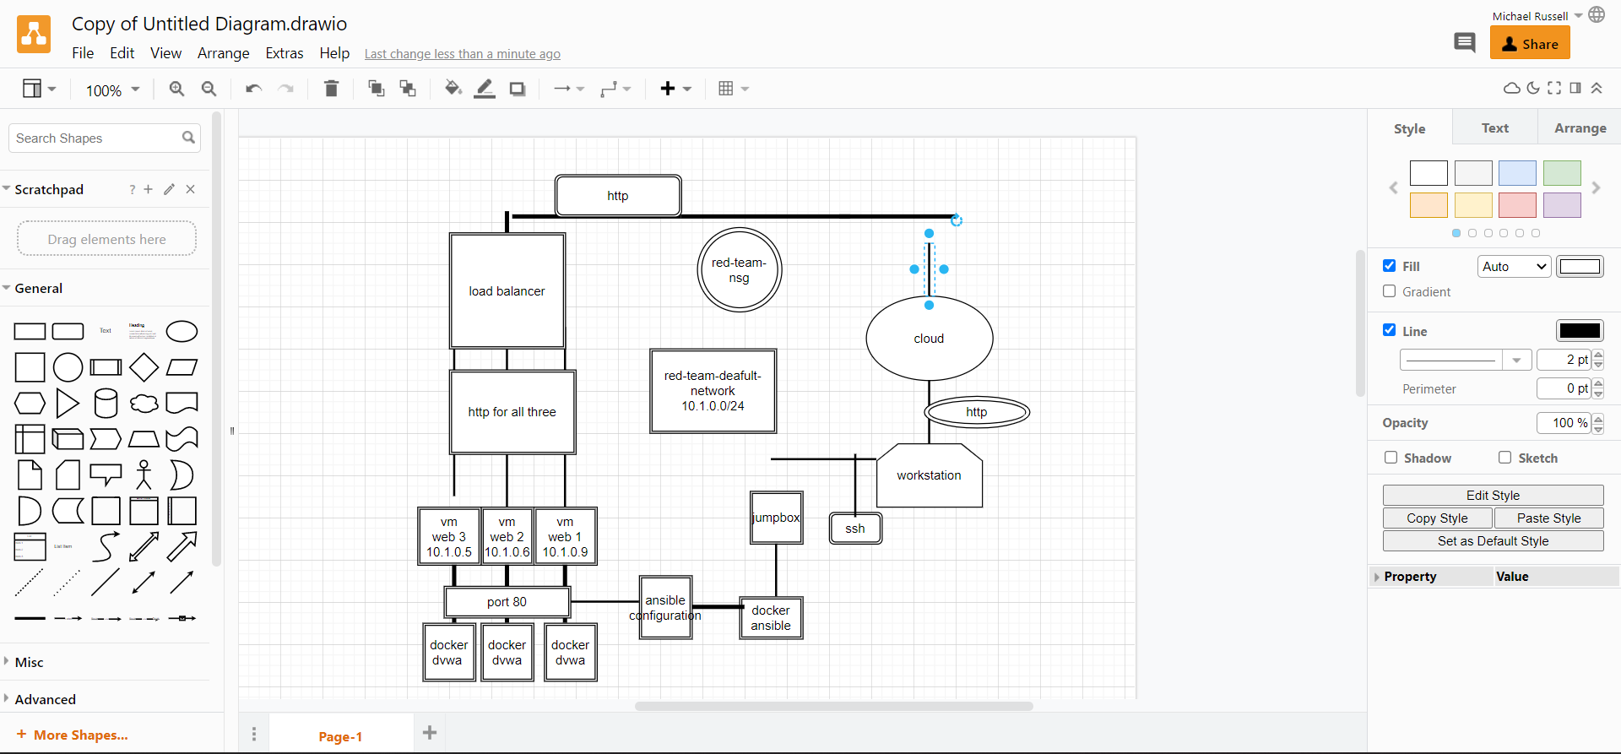

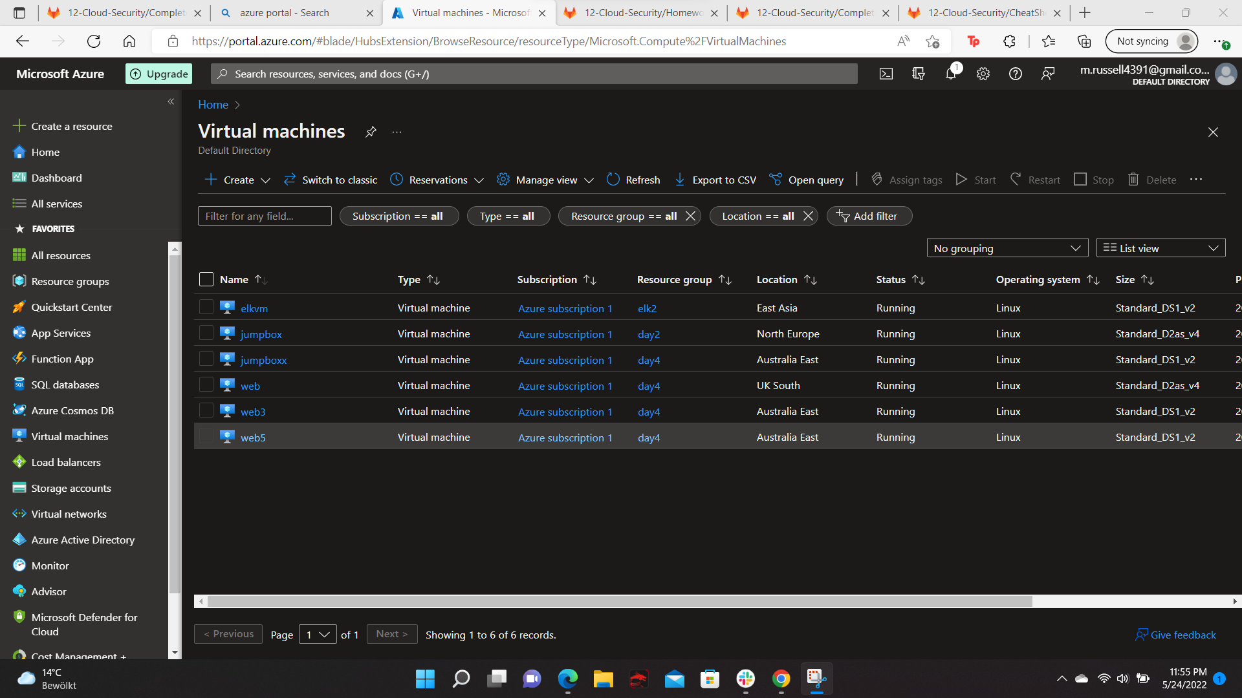

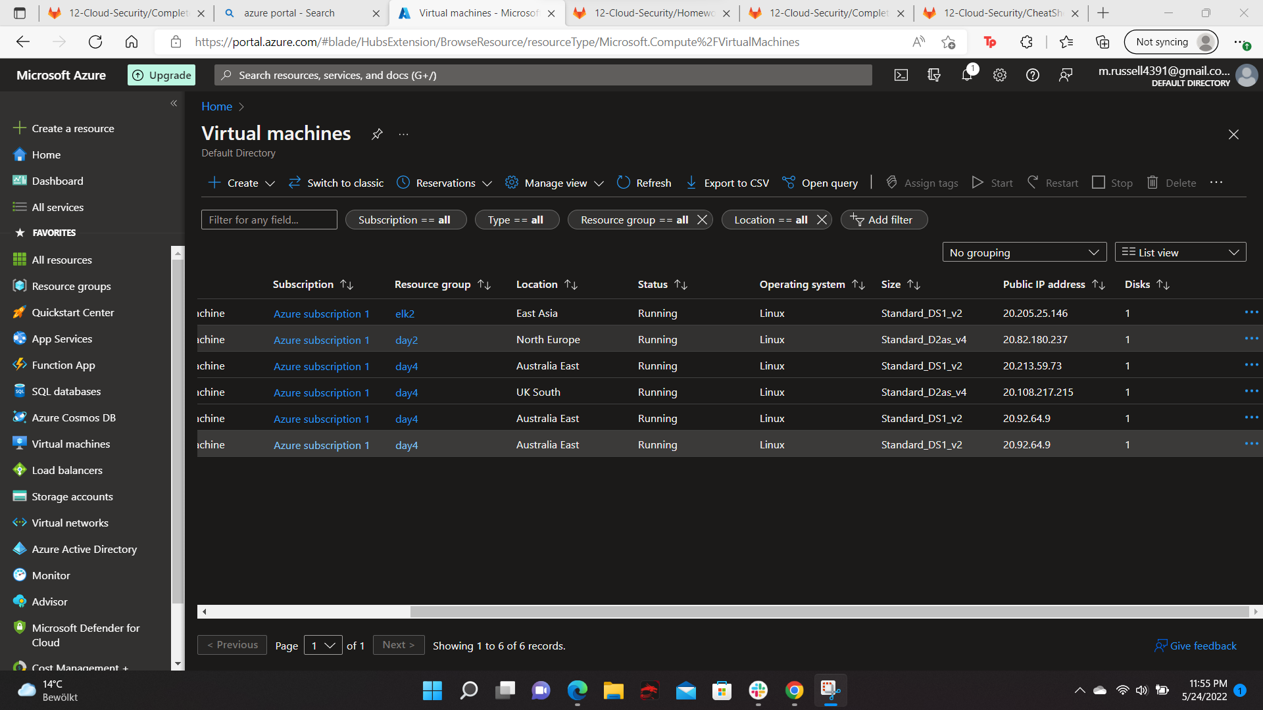

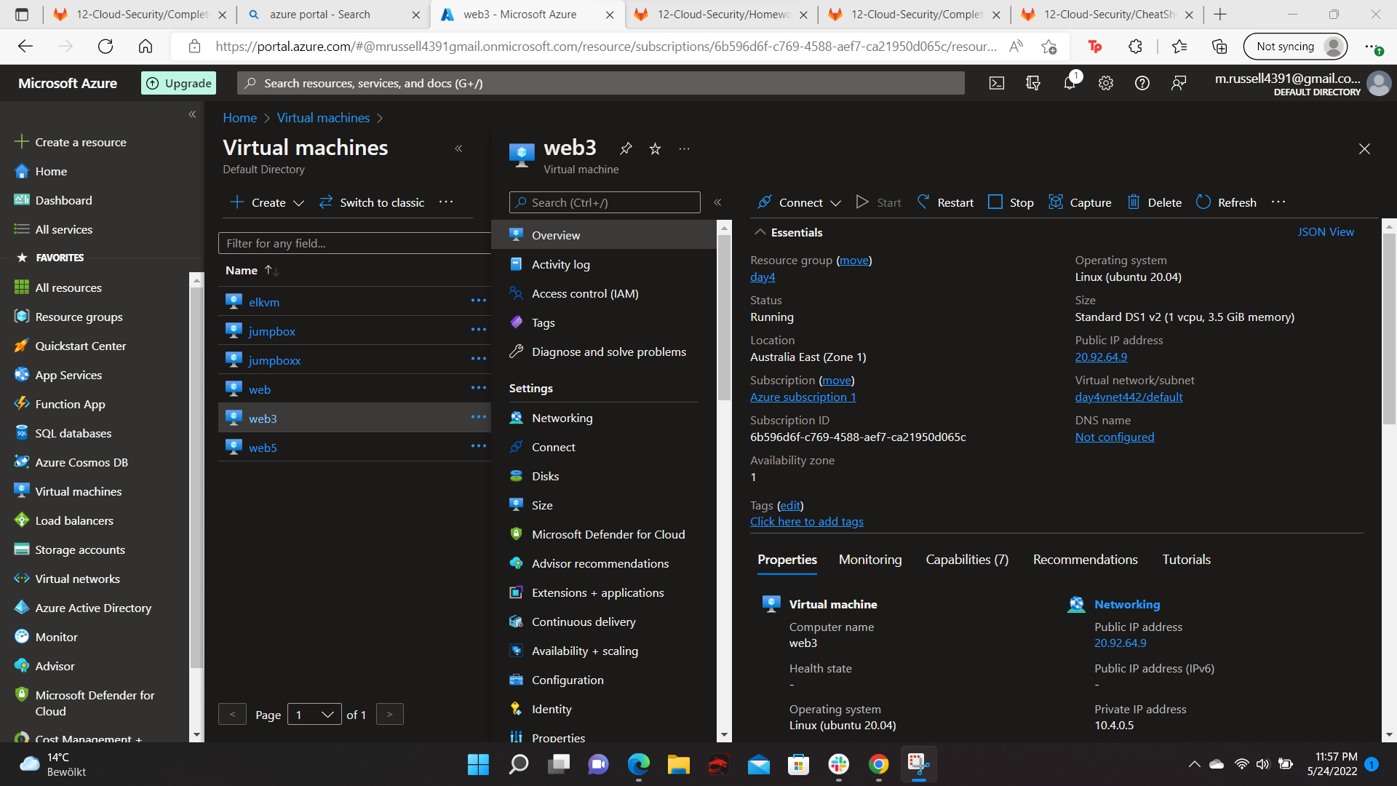

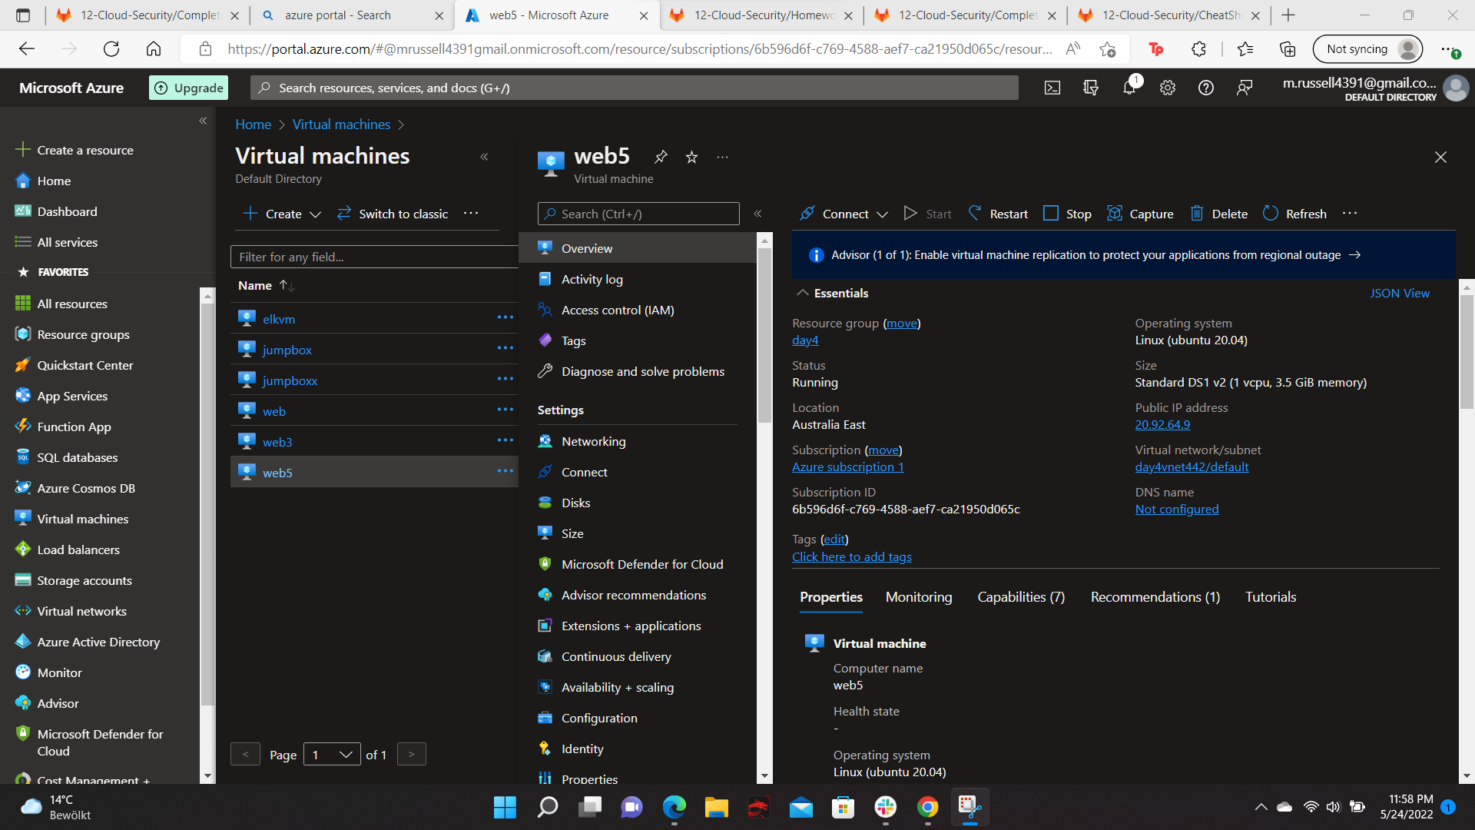

Your diagram should show the following:

* Azure resource group day 4
* Virtual network with IP address range 20.92.64.9
* Subnet range day4vnet442/default
* Flow of specific traffic (e.g., HTTP, SSH) http
* Security group blocking traffic web2-nsg
* Load balancer
* All 4 VMs that you have launched - web3 and web5
* Where Docker and Ansible are deployed